**AWS :**

**S3 MULTIPART UPLOAD**

S3 multipart upload basically uploads one file into its multiple parts by dividing them in no of pieces of similar sizes.

Step 1: login to aws management console and open the cloudshell or aws cli.both works the same .Here we choose cloudshell to run our commands .

Step 2: first make a bucket using the following command:

#name the bucket

BUCKET_NAME=**yourbucketnamehere**

#create a bucket

aws s3 mb s3://$BUCKET_NAME

Step 3: now navigate to s3 and check whether a bucket with the same name as you entered will have a bucket in s3.

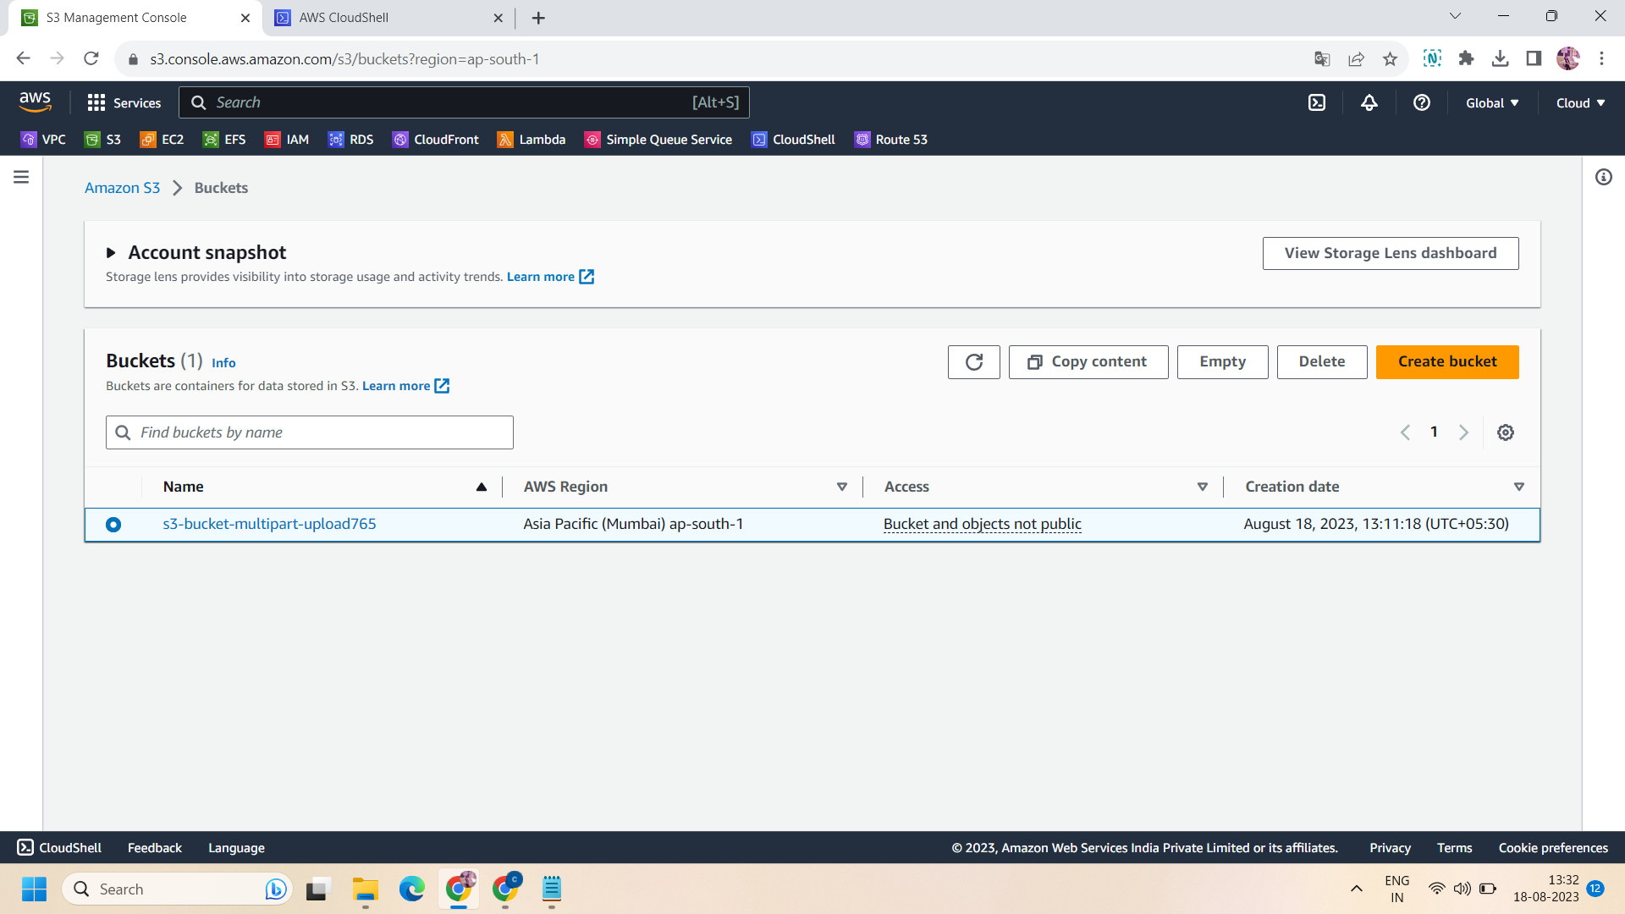

Step 4: Then we will first generate a file of 100 MB before uploading it into bucket.to generate the file run the following command :

# Generate a 100 MB file

dd if=/dev/zero of=100MB.txt bs=1MB count=100

Step 5: as we want to do multipart uploading ,so we have to first divide the file into 3 parts .It is not necessary to divide the file only into 3 parts ,we can divide into 2 or 4 pieces to but here we divide into 3 parts of 35 MB .To do so ,apply following:

# Split it into 3 parts of 35 MB

split -b 35m 100MB.txt 100MB_part_

Step 6: now we have to start the uploading ,for this apple following command:

# Initiate the multi-part upload

aws s3api create-multipart-upload --bucket $BUCKET_NAME --key 100MB.txt

Step 7: after initiating,we need upload id to specify the upload id .so the upload id we will get from the previous command .as when we run the command for initiate multipart in that command as output ,we get an upload id so copy it and replace it in the following command and run the cloudshell.

# get back the upload_id and insert it below

UPLOAD_ID=**LO99SQpq7LSDaMiArIV0SWCUlc3fyCBXflTX8yfae8Ux62y2nkceBXProyeV54kN4SIajjOZvE7x8btrohRLXpJKcu0vQd7oomr2ATVu8iTC.lFc4nPDLvwZVpFMoqL9AXiXuQPYANbIw8jT.7q42A–**

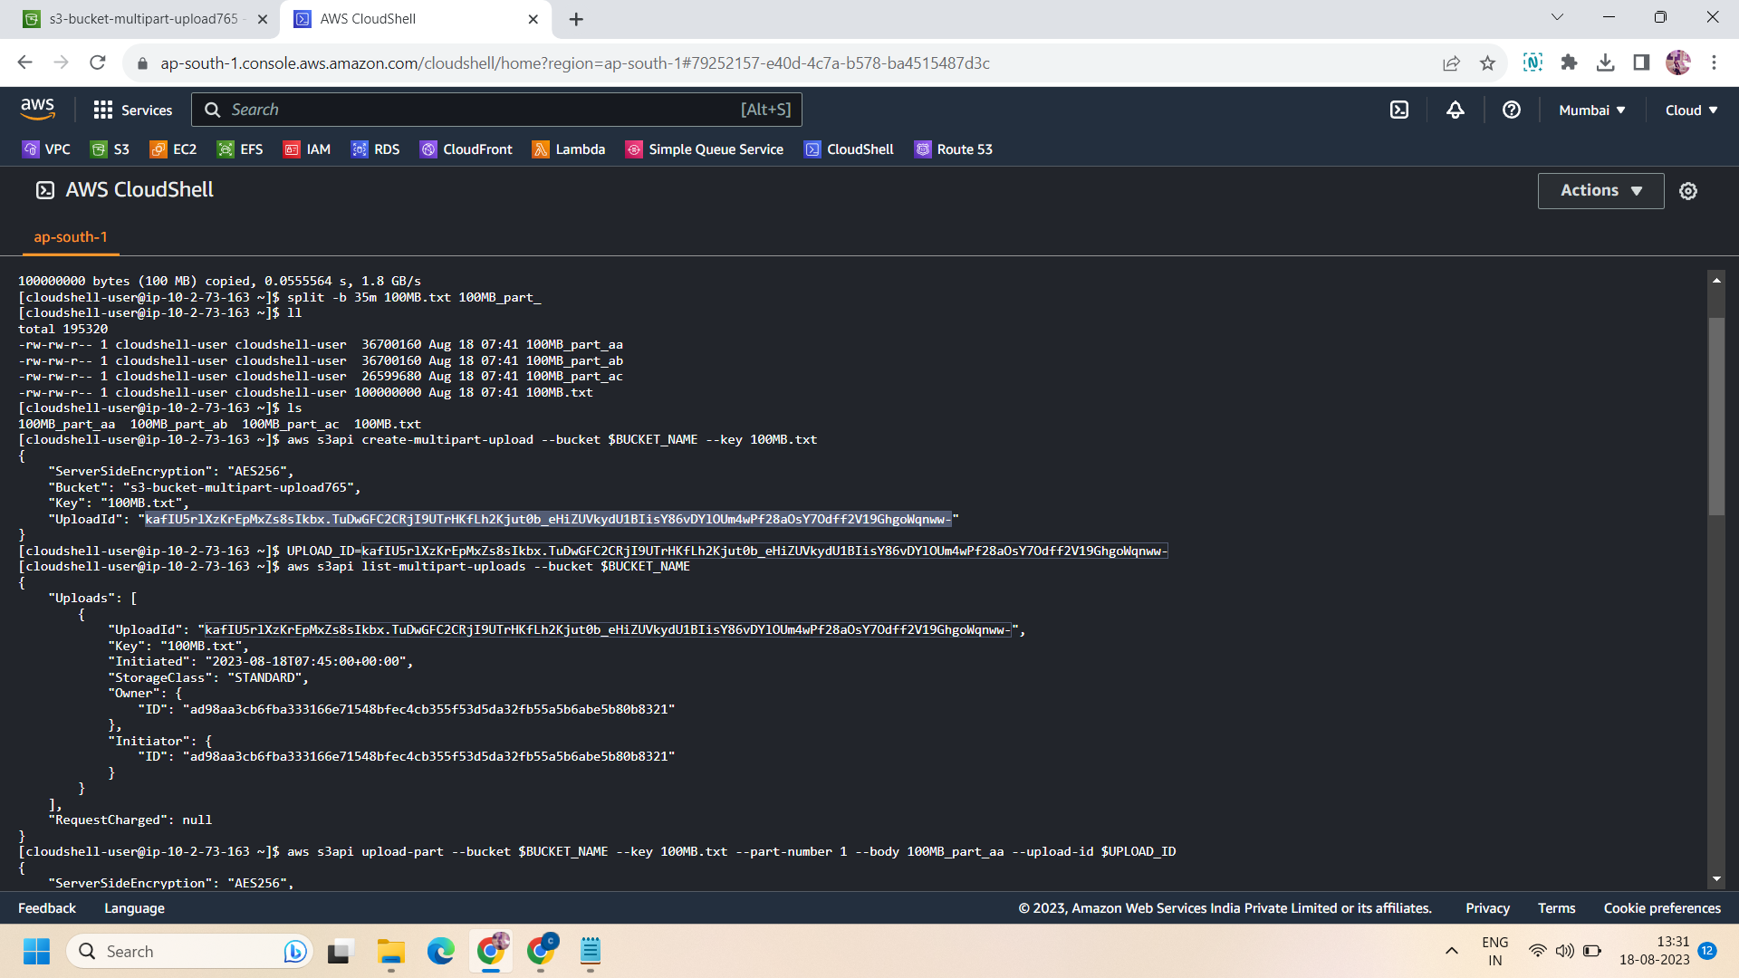

Step 8: now we want to list the existing multipart uploads .so run the following command:

# list existing multi part uploads

aws s3api list-multipart-uploads --bucket $BUCKET_NAME

Step 9: now it's time to upload the file ,but here we can’t upload the file in one part ,as we already split the file into three parts ,so we have to upload the file into 3 pieces as it is. So ,for this apply following commands:

# Upload the parts

aws s3api upload-part --bucket $BUCKET_NAME --key 100MB.txt --part-number 1 --body 100MB_part_aa --upload-id $UPLOAD_ID

aws s3api upload-part --bucket $BUCKET_NAME --key 100MB.txt --part-number 2 --body 100MB_part_ab --upload-id $UPLOAD_ID

aws s3api upload-part --bucket $BUCKET_NAME --key 100MB.txt --part-number 3 --body 100MB_part_ac --upload-id $UPLOAD_ID

Step 10: now after uploading every part ,we want to list them .so run the following command :

# list the parts

aws s3api list-parts --upload-id $UPLOAD_ID --bucket $BUCKET_NAME --key 100MB.txt

Step 11: Now after uploading every part and listing them ,we have to complete this multipart uploading for doing so ,apply the following command but before applying this command ,you have to first enter the etags of every part.

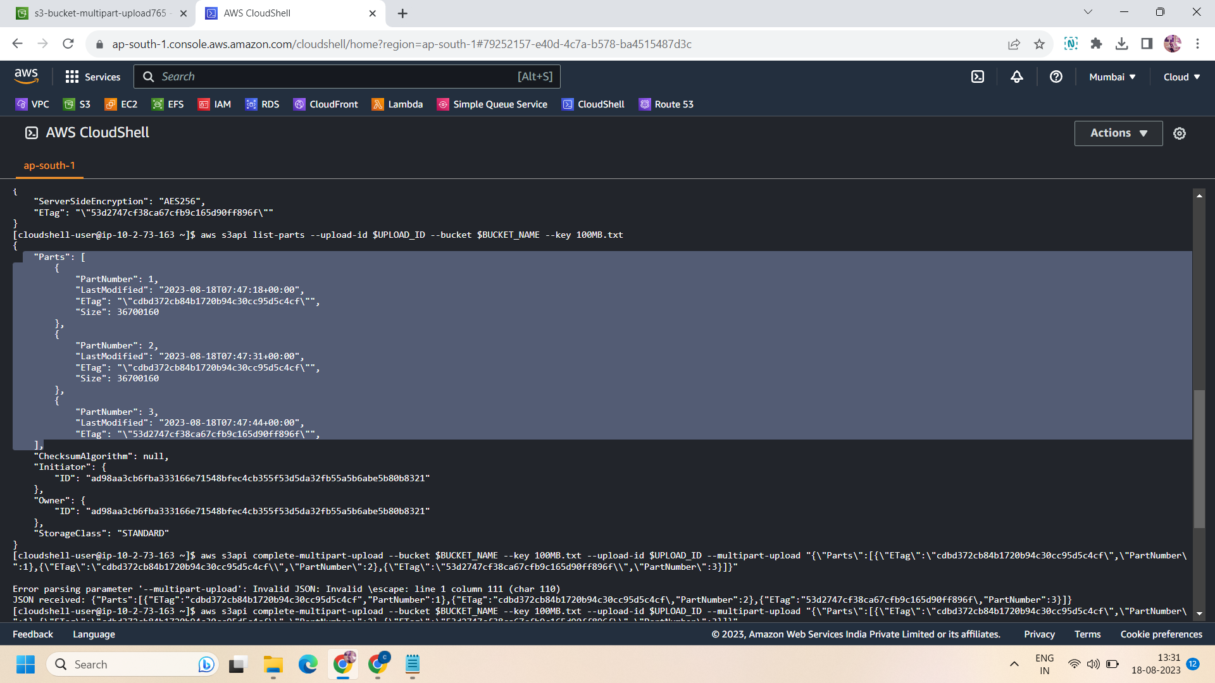

Etags are assigned to every part of file and we will get them from the previous command when we list the parts we will get the etag of every command so command all the etags(etag1,etag2 and etag3) then replace it in the following command and then run it:

# Complete multipart upload

aws s3api complete-multipart-upload --bucket $BUCKET_NAME --key 100MB.txt --upload-id $UPLOAD_ID --multipart-upload "{\"Parts\":[{\"ETag\":\"**etag1**\",\"PartNumber\":1},{\"ETag\":\"**etag2**\",\"PartNumber\":2},{\"ETag\":\"**etag3**\",\"PartNumber\":3}]}"

Step 12 : Now after running the above command ,if you go to bucket and check for an object ,you will get a file of 100 MB that we upload by splitting it into multiparts.

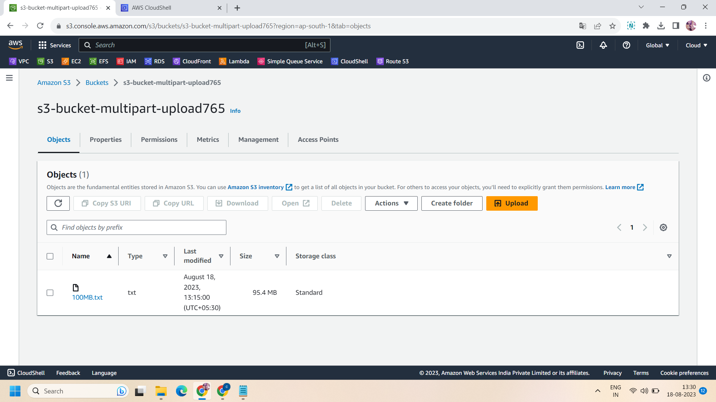

All done!!

NOTE: all the bold statements need to be edited.